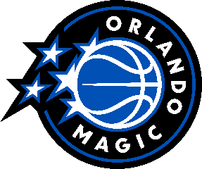
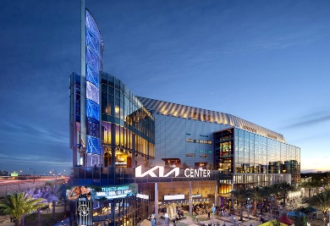
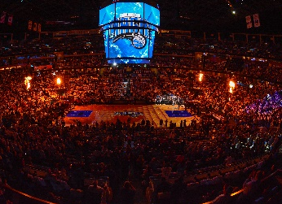
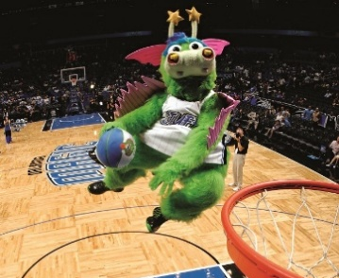
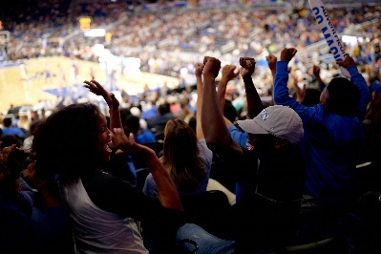
Orlando Magic
Take in the total NBA experience: world-class basketball, edge of your seat excitement, fun for all ages, and more. Experience Orlando like the locals by attending a game in the heart of downtown. It’s more than just the action of a basketball game—it’s experiencing all the Orlando Magic has to offer. In-game entertainment for fans of all ages makes an unforgettable experience for the whole family.

World-Class Basketball
From October to April experience the thrills of super-charged action as the Orlando Magic take on the biggest teams in the NBA. See matchups against teams such as the Los Angeles Lakers, Boston Celtics, Chicago Bulls, Golden State Warriors and others in the Kia Center – a state-of-the-art sports facility featuring interactive fan areas and a restaurant that overlooks the court.

Entertainment
You don’t have to be a sports enthusiast to enjoy the action of an Orlando Magic basketball game! Packed with fun for the whole family, experience a sensational pregame light and video show and halftime performances that feature unbelievable talent. There’s non-stop fun with entertainment during every break in the action. Choose from several unique bars and restaurants featuring mouth-watering options from fine dining to traditional game day food and drinks and everything in between. Don’t forget to stop at the “Magic Authentics” Team Store for official merchandise to take your memories of Magic home with you!

Unique Group Experiences
Make your event even more memorable by reserving a unique group experience. Choose an on-court group photo or cut down the nets after the game and take a piece of the action home with you!

Plan now to make a Magic game part of your Orlando vacation!

Location: 400 West Church Street, Orlando, FL 32801
To find the Orlando Magic schedule: www.orlandomagic.com

