ORLANDO MAGIC TOURISM SEATING AREAS
ULTIMATE SEATING
Sit close to the action at an Orlando Magic game in the Ultimate seats! Located in the first 7 rows, these seats have amazing views and put you close to the NBA players. Ultimate seats come with access to our exclusive Fields Ultimate lounge, which includes all-inclusive food and beverage (beer, wine, soda) throughout the game. Food and beverage service starts an hour and a half before tip-off, so come early and enjoy dinner in the lounge before the game.

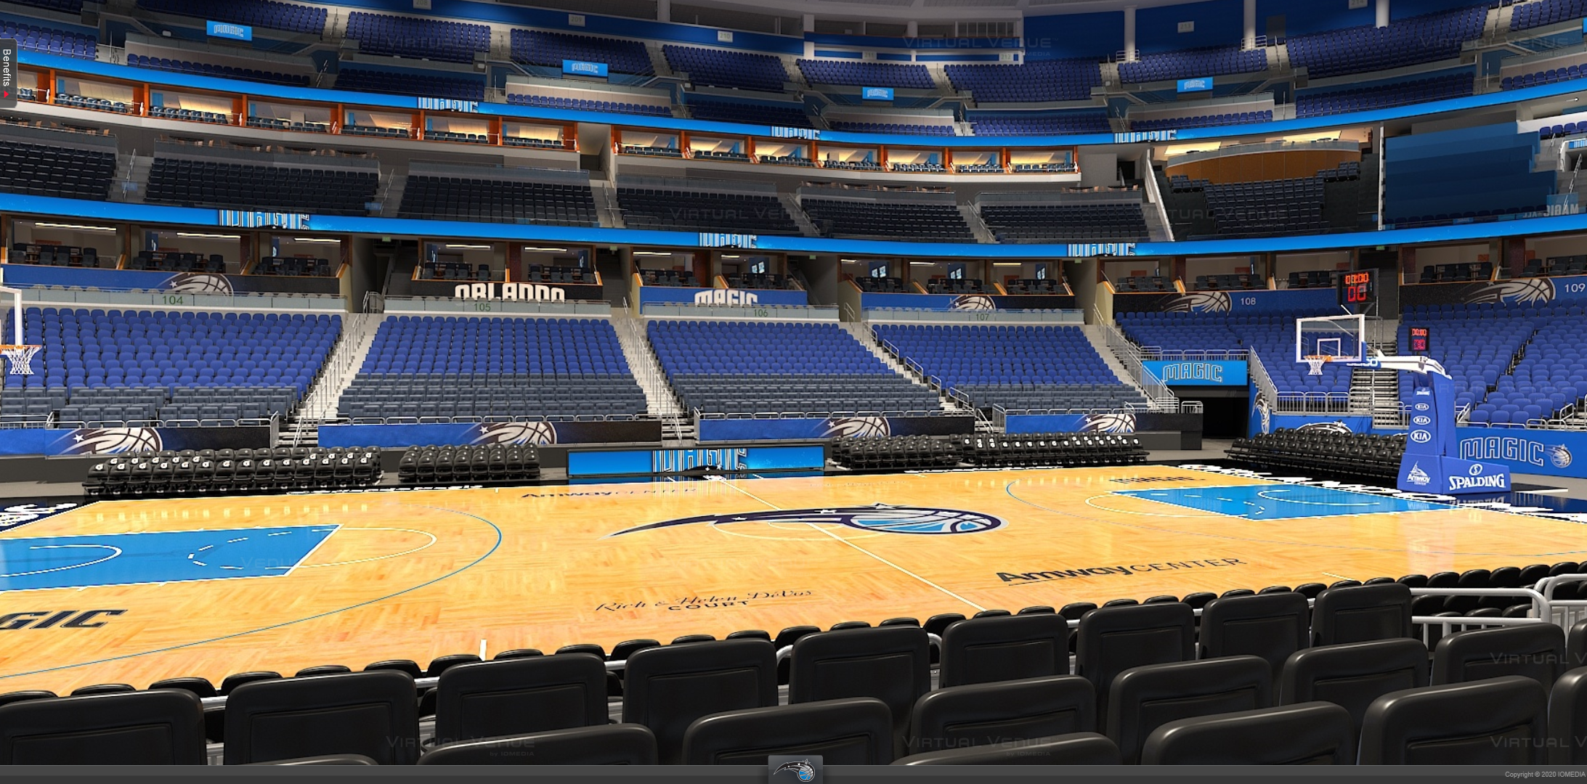
TERRACE A
Terrace A seating offers incredible sideline & corner views, while being only 8-18 rows from the court. Receive the quintessential Orlando Magic experience, immersed in the action and excitement of an NBA game!

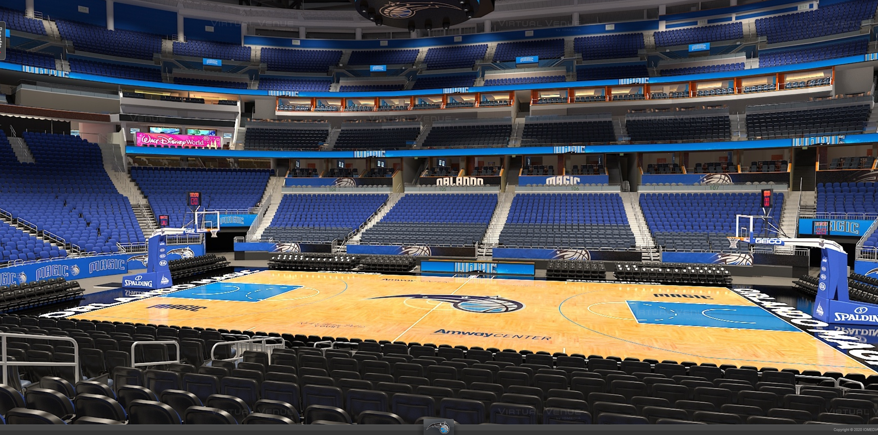

TERRACE B
Terrace B seating offers great views behind the north and south baskets. This is the most affordable seating option in the lower bowl of the arena. Sit behind the south basket, and enjoy easy access to the Bud Light Baseline Bar.

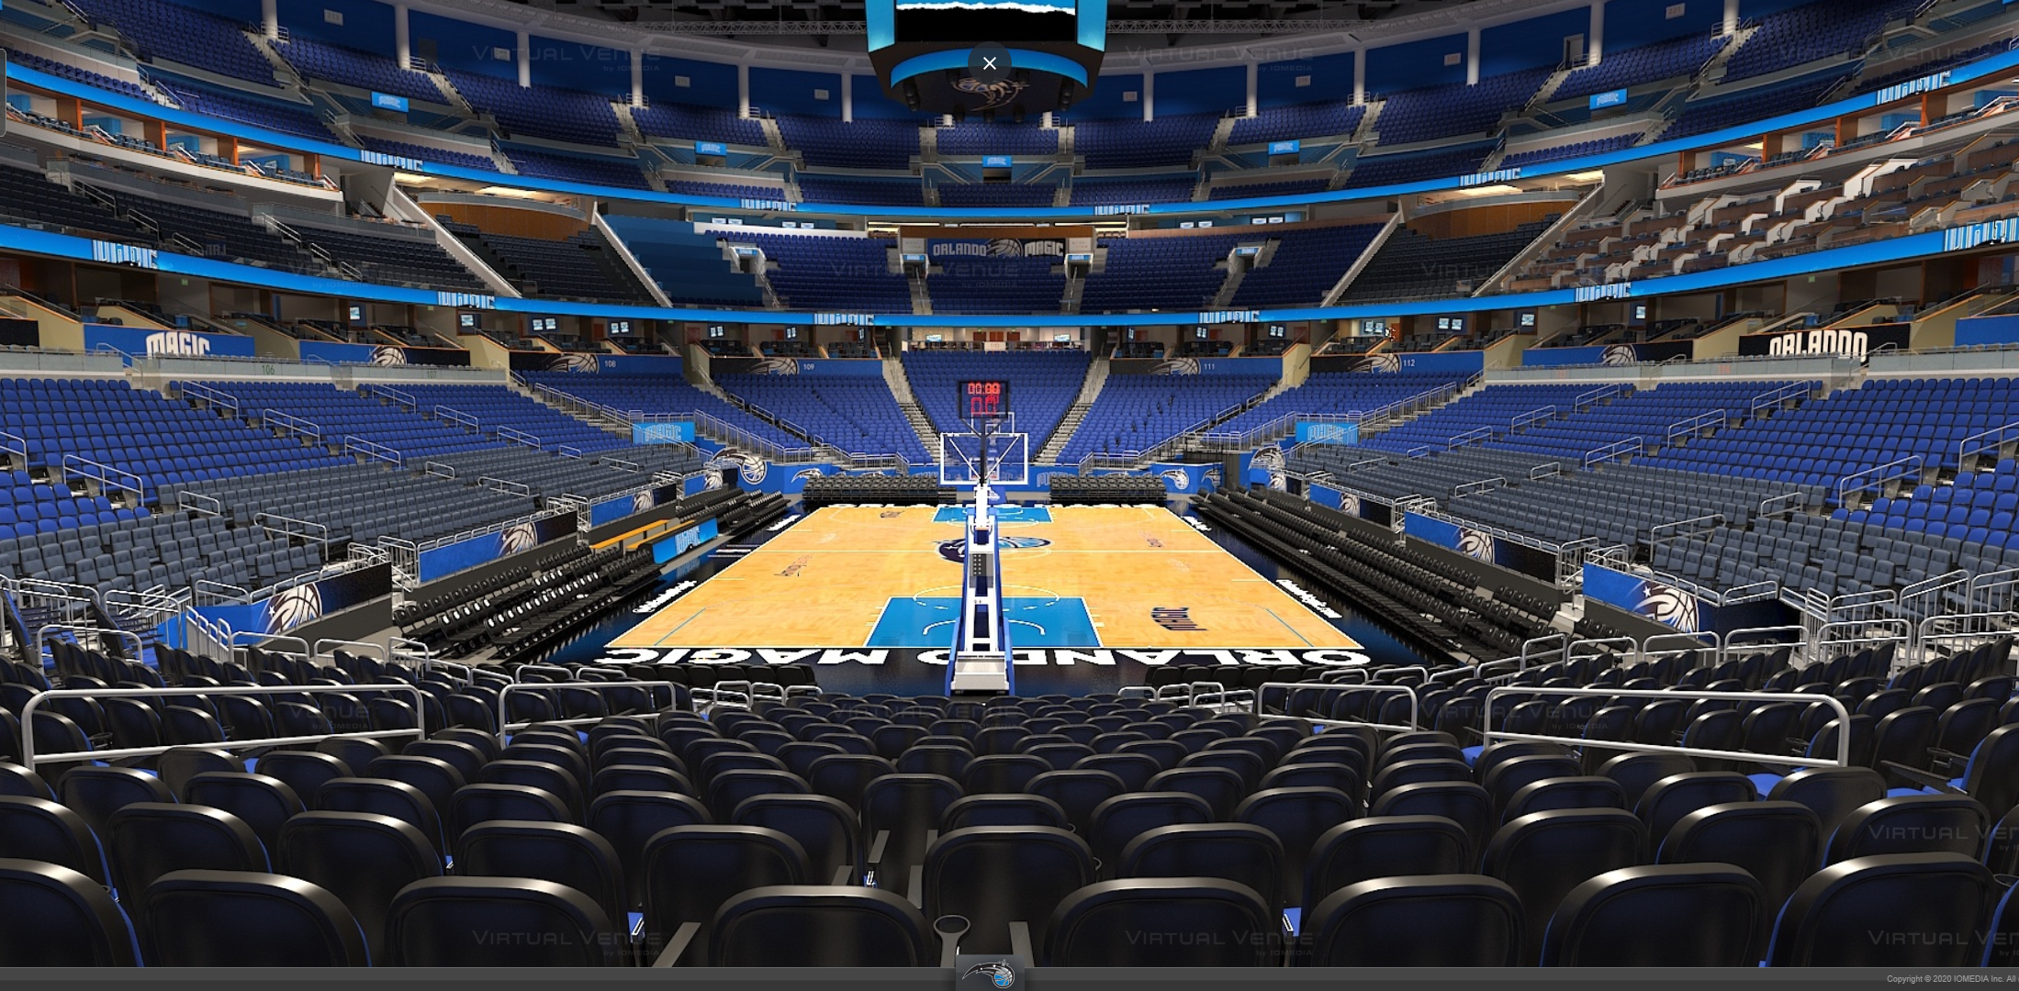
CLUB
Located on the private Club level of the arena, club seats are a more premium seating option. Guests can enjoy sideline views, while sitting in spacious leather back seats. The club level features multiple luxurious lounge spaces and bars, in addition to higher-end concessions options.

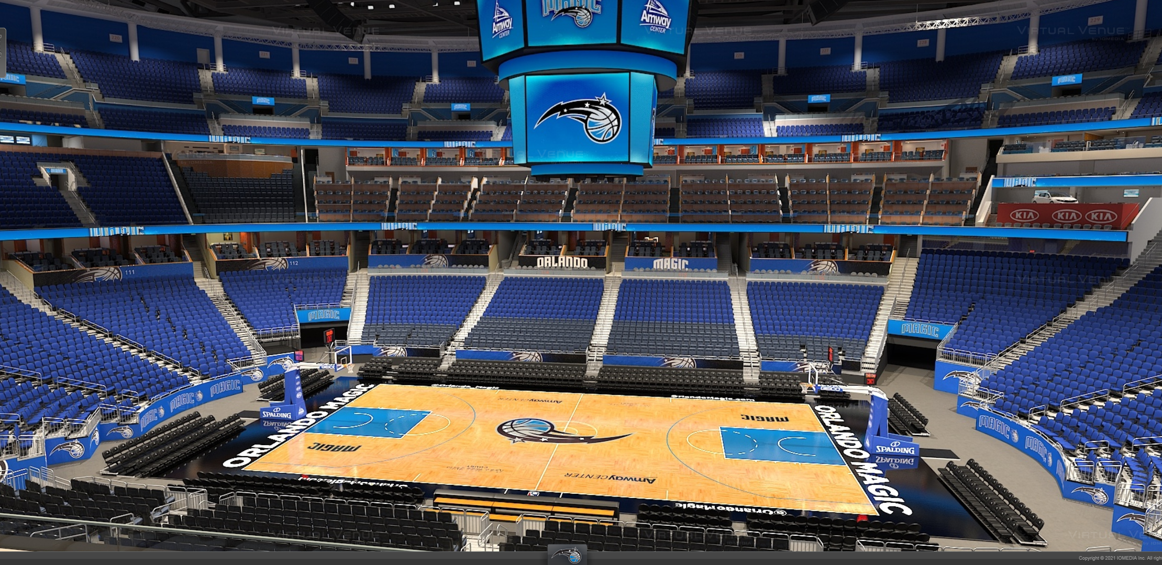

PROMENADE A
Promenade A seats are the preferred upper bowl seating area. These seats offer great views from the upper level sidelines or corners.

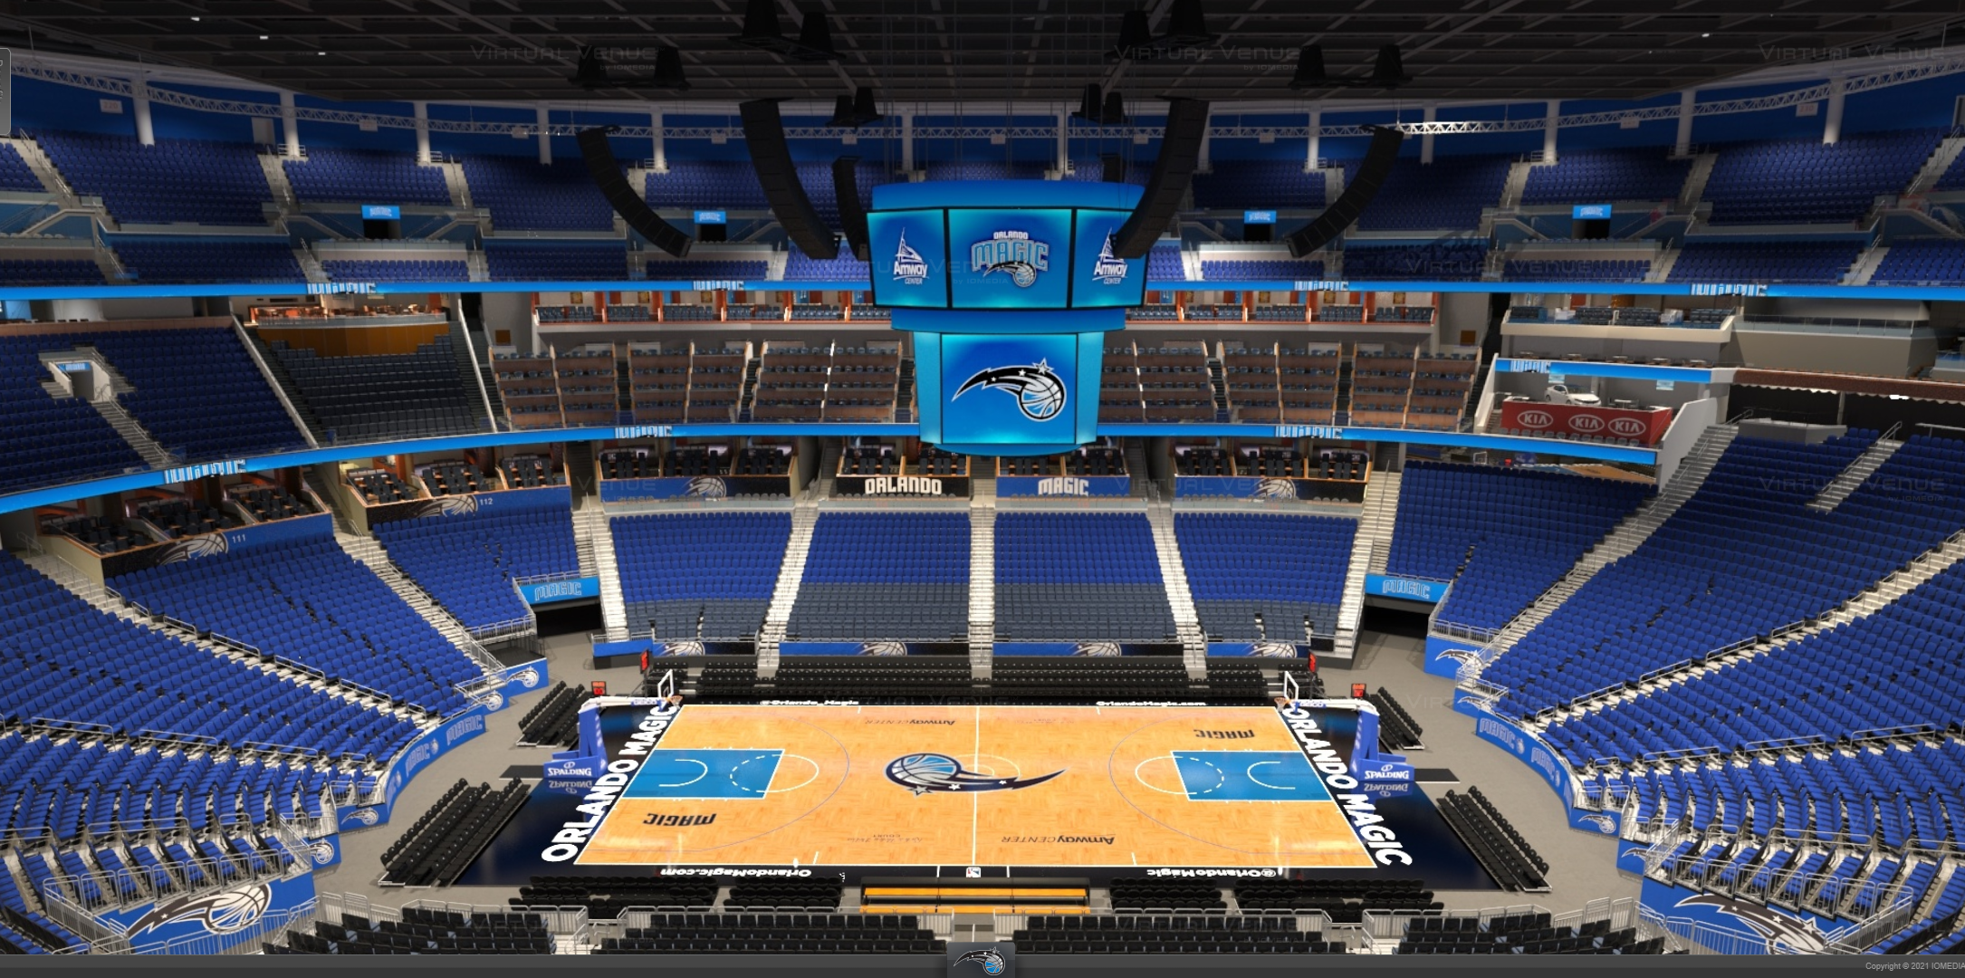

PROMENADE B
Promenade B seats are a fun, affordable option for any family or group. Sit in the upper bowl of Amway Center to experience a full view of the game action. These sections range from sideline to corner views of the court. The Promenade level features the Ozone Bar and a variety of concessions options.

